

Outdoor Learning UK
In association with
Forest Schools Birmingham CIC

OCN Level 3 Forest Schools Award

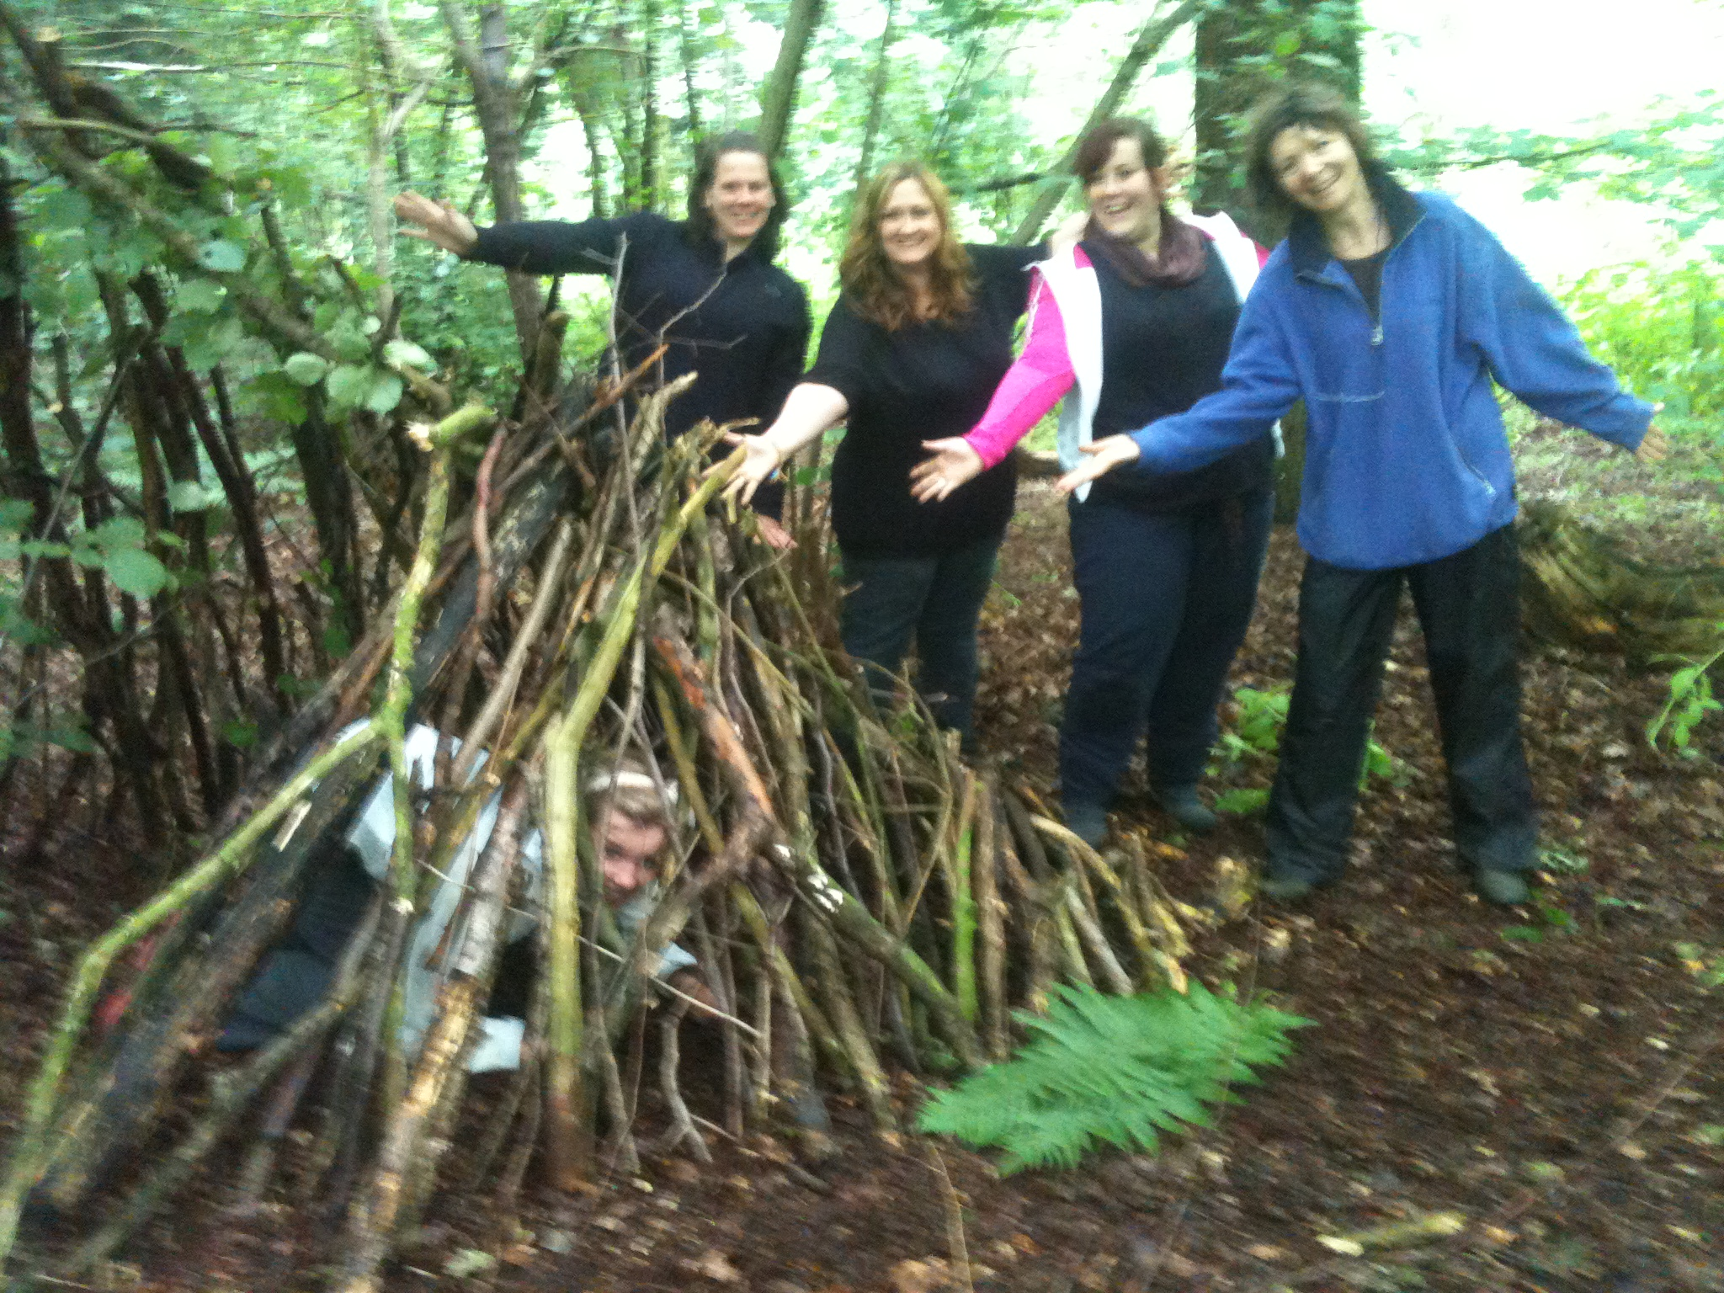
Here at Outdoor Learning UK and Forest Schools Birmingham CIC, we are more than just a training company, we are a community and a support network. We intend to support you throughout your practice; whether that is help planning a site, support in your setting, INSET, providing supporting practitioners or just a place to ask questions and advice. We are here for the journey.
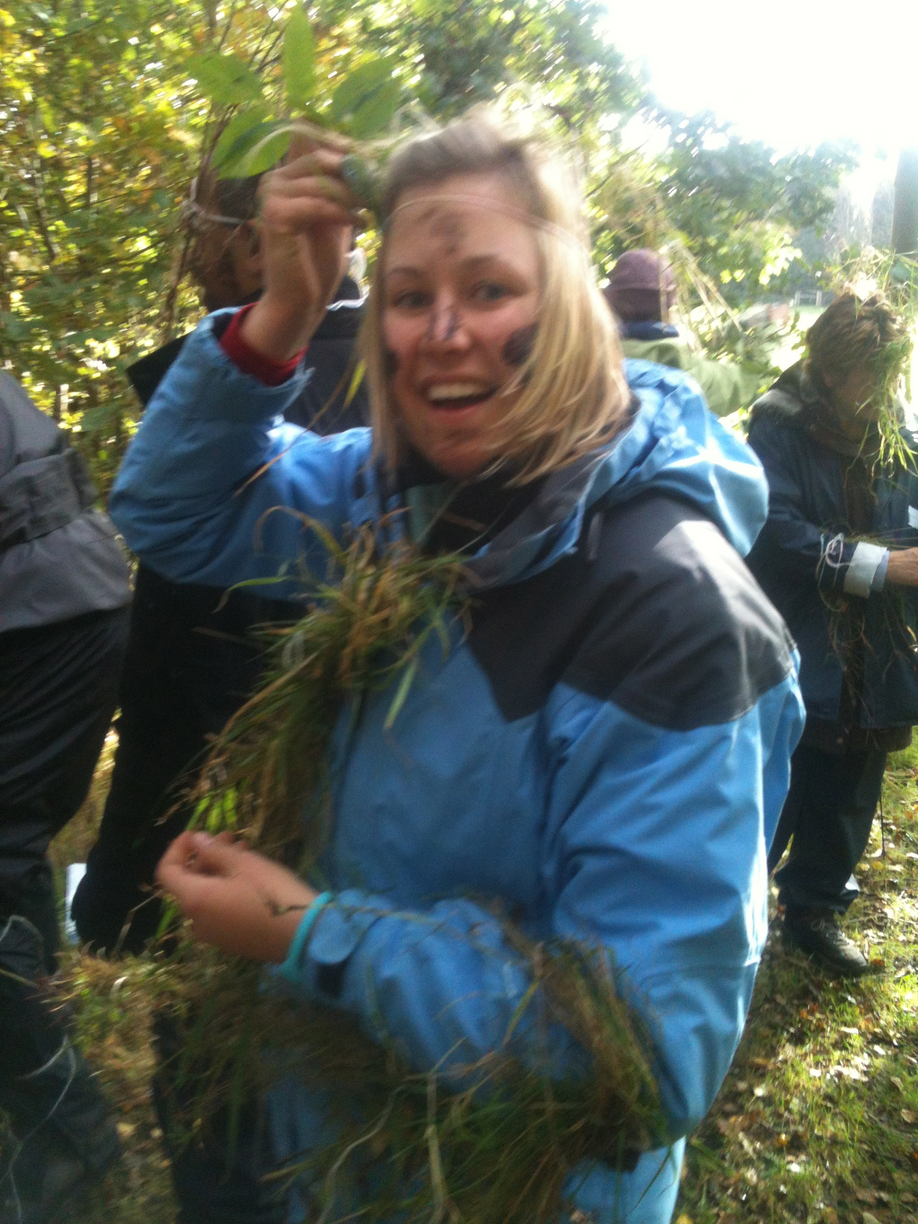

Our Forest Schools training is of the very highest standard with practical skills and safety at its backbone, underpinned with sound and engaging development theories. Not only are we providers of training, we are also one of the longest standing and most successful deliverers of Forest School programmes to children in the UK. We have worked with 160+ schools over the last 16 years. We are also an award winning charitable organisation, having been awarded ‘Birmingham’s Greenest Business’ two years consecutively by the Birmingham Green Commission.

Training consists of a 5 day initial training period, a personal development and portfolio period of 6 months, and ends with a 5 day assessment. You will then have a further 3 months to finish your portfolio.

The training is outdoor based where we have you ‘doing’ as you learn; this way our trainees come away with a practical, kinaesthetic working knowledge of all aspects of Forest Schools, including sound practical skills and a thorough understanding of the theories and benefits relating to good Forest Schools practice.

Throughout your 9 month training period, we will keep in touch regularly to guide you through the training. We want to give you help and support along the way, to keep you on track; helping to build your confidence and skills. Our aspiration is that when you complete your qualification, you will feel confident to go out and run your own Forest School programme, for anyone, anywhere!

What our training consists of:

Initial Training Period – Week 1

- Understanding the learning theories which underpin quality Forest Schools practice.
- Applying these theories in everyday practice.
- Site selection, site set-up and woodland management.
- Aspects of sustainability.
- Use of fire in an education setting.
- Safe effective use of tools.
- Risk assessment and health and safety protocol associated with Forest Schools and outdoor learning.
- General management and administration of a successful Forest School.
- Behaviour management.
- Tutorial of portfolio requirements.
- Being successful, engaging and innovative in the outdoors.
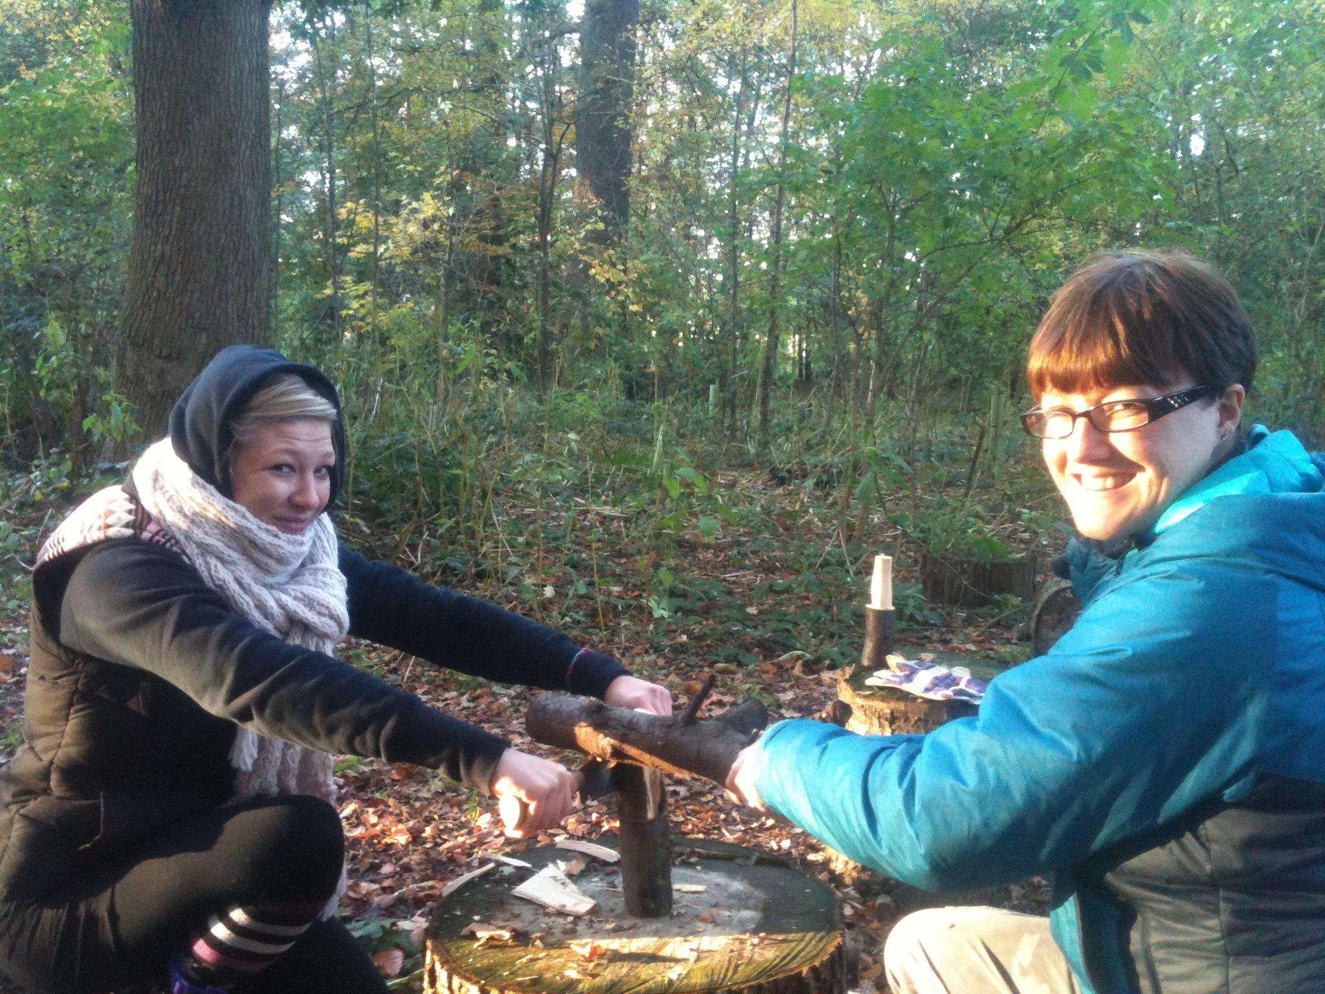
Consolidation and Portfolio Period – 6 Months

- Plan, deliver and evaluate a minimum of 6 Forest School sessions employing the techniques outlined in Initial training period.
- Practice, refine and become confident in practical skills.
- Complete portfolio of evidence

Assessment Training Period – Week 2

- Assessment across all practical applications of forest schools; including tools, fire, ethos.
- You will be required to plan and deliver an hour long Forest Schools session on which will be assessed.
- Feedback and portfolio questions.

Please note that in order to complete your qualification; you must hold a 1st Aid Certificate in either:

- Paediatric 1st Aid
- Outdoor First Aid

